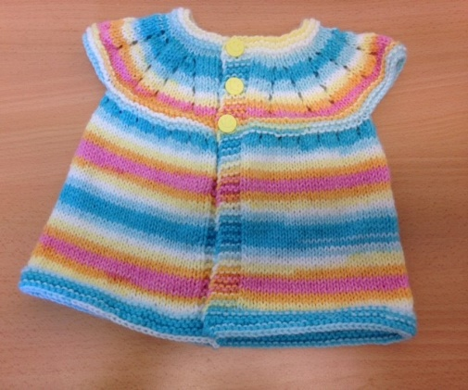TOP DOWN CARDIGAN FOR BABY 3-6 MONTHS

Cast on 69 stitches

Rows 1 & 2 Knit

Row 3 K2, yfwd, k2 tog, (makes a buttonhole) knit to end of row

Rows 4 & 5 Knit

Row 6 K5, purl to last 5 sts, k5

Row 7 Knit

Row 8 K5, purl to last 5 sts, k5

Row 9 K9, \*(yfwd, k1, yfwd, k4) rep from \* to last 5 sts, k5 91 sts

Row 10 k5, purl to last 5 sts, k5

Row 11 Knit

Row 12 K5, purl to last 5 sts, k5

Row 13 k9, \*(yfwd, k3, yfwd, k4) rep from \* to last 5 sts, k5 113 sts

Row 14 k5, purl to last 5 sts, k5

Row 15 k2, yfwd, k2 tog, (makes a buttonhole) knit to end of row

Row 16 k5, purl to last 5 sts, k5

Row 17 k9, \*(yfwd, k5, yfwd, k4) rep from \* to last 5 sts, k5 135 sts

Rows 18, 19, 20 As rows 10, 11, 12

Row 21 k9, \*(yfwd, k7, yfwd, k4) rep from \* to last 5 sts, k5 157 sts

Rows 22, 23, 24 As rows 10, 11, 12

Rows 25, 26 Knit

Row 27 k2, yfwd, k2 tog (makes a buttonhole) knit to end of row

Row 28 Knit

Row 29 Knit

Row 30 k26, cast off 28 sts, k48, cast off 28 sts, k25

Row 31 Knit (26 sts from front, 49 sts from back, 26 sts from front) 101 sts

Row 32 k5, purl to last 5 sts, k5

Row 33 k5, (k3, m1) to last 6 sts, k6 131 sts

Row 34 k5, purl to last 5 sts, k5

Row 35 Knit

Row 36 k5, purl to last 5 sts, k5

Repeat last two rows until work measures 23cm (9”) in length

Knit 5 rows

Cast off loosely

Darn away ends

Sew on buttons